### A PROJECT REPORT ON

**Pneumonia Detection and Classification using VGG16 Module**

Submitted to the Savitribai Phule Pune University, Pune in the partial fulfillment for the award of the degree

**BACHELOR OF ENGINEERING In**

**(Information Technology)**

**By**

Karan Vasant Nakum B150438541

Gopal Sanjay Paraskar B150438545

Pavan Shatrughna Patil B150438548

Hrushikesh Sadanand Rajankar B150438553

**Under The Guidance of**

**Dr. Sunil L. Bangare**



**DEPARTMENT OF INFORMATION TECHNOLOGY**

**Sinhgad Academy of Engineering Kondhwa, Pune, Maharashtra, India, 2021-2022**



**CERTIFICATE**

This is to certify that the project report entitled

**Pneumonia Detection and Classification using VGG16 Module**

Submitted by

Karan Vasant Nakum B150438541

Gopal Sanjay Paraskar B150438545

Pavan Shatrughna Patil B150438548

Hrushikesh Sadanand Rajankar B150438553

is a bonafide student of this institute and the work has been carried out by him/her under the supervision of **Dr. S. L. Bangare** and it is approved for the partial fulfillment of the requirement of Savitribai Phule Pune University, for the award of the degree of Bachelor of Engineering (Information Technology)

### **Dr. S. L. Bangare** **Dr. S. S. Kulkarni**

Guide HOD

**ACKNOWLEDGMENT**

It gives us great pleasure in presenting the preliminary project report on

**‘Pneumonia Detection and Classification using VGG16 Module’**

I would like to take this opportunity to thank my internal guide **Dr. S. L. Bangare** Department of Information Technology, Sinhgad Academy of Engineering, for his un- conditional guidance. I am really grateful to them for their kind support. Their valuable suggestions were very helpful

An erudite teacher, a magnificent person and a strict disciplinarian, we consider our- selves fortunate to have worked under her supervision. We are thankful to Honorable Principal, Sinhgad Academy of Engineering,

**Dr. K. P. Patil** for the support.

We are highly grateful to **Dr. S. S. Kulkarni,** Head of Department, Information Technology, Sinhgad Academy of Engineering, for indispensable support, suggestions.

We admit thanks to project coordinator, Department of Information Technology, Sinhgad Academy of Engineering for giving us such an opportunity to carry on such mind stimulating and innovative Project.

Karan Vasant Nakum B150438541

Gopal Sanjay Paraskar B150438545

Pavan Shatrughna Patil B150438548

Hrushikesh Sadanand Rajankar B150438553

**ABSTRACT**

The infectious illness known as Pneumonia is regularly a result of contamination because of a bacterium in the alveoli of the lungs. While an infected tissue of the lungs has an infection, it builds up pus in it. To find out if the patient has those illnesses, professionals perform bodily exams and diagnose their patients through Chest X-ray, ultrasound, or biopsy of lungs. Misdiagnosis, erroneous treatment, and if the disease is overlooked will result in the patient’s lack of lifestyle. The progression of Deep learning contributes to aid in the decision-making procedure of specialists to diagnose sufferers with these illnesses. The look employs a bendy and efficient technique of deep learning of applying the model of CNN in predicting and detecting a patient unaffected and affected with the sickness using a chest X-ray photograph. The take a look at utilising an accrued dataset of 20,000 images using a 224x224 photograph decision with 32 batch length is applied to prove the overall performance of the CNN model being educated. The trained-version produced an accuracy charge of 95% at some point of the overall performance training. Based on the end result of the experiment carried out, the research study can detect and are expecting COVID-19, bacterial, and viral-pneumonia sicknesses based totally on chest X-ray photos.

# **LIST OF FIGURES**

|  |  |  |
| --- | --- | --- |
| **Sr. No.** | **Name of Figure** | **Page Number** |
| 3.1 | Waterfall Model | 10 |
| 4.1 | Use Case diagram | 13 |
| 4.2 | Class Diagram | 14 |
| 4.3 | Sequence diagram | 15 |
| 4.4 | Activity Diagram | 16 |
| 4.5 | State Diagram | 17 |
| 5.1 | Examples from the dataset. (a) normal cases, (b) pneumonia case set | 18 |
| 5.2 | Details of proposed DL mode | 19 |
| 6.1.1 | Setting up Kaggle in Colab | 20 |
| 6.1.2 | Importing dataset from Kaggle in Colab | 20 |
| 6.1.3 | Extracting downloaded dataset in Colab | 20 |
| 6.2.1 | Defining parameters for Data Augmentation | 21 |
| 6.2.2 | Applying defined parameters to train, test and valid sets | 21 |
| 6.2.3 | Augmented Dataset Images | 22 |
| 6.3 | ResNet-50 | 23 |
| 6.4 | AlexNet | 23 |
| 6.5 | VGG16 | 23 |
| 7.1 | Augmented Dataset | 24 |
| 7.2 | Confusion Matrix | 26 |
| 7.3 | Predicted Images | 27 |
| 7.4 | Streamlit UI | 28 |

# **LIST OF TABLES**

|  |  |  |
| --- | --- | --- |
| **Sr. No.** | **Name of Figure** | **Page Number** |
| 1 | Literature Survey | 4 |
| 2 | Data Pre-Processing | 19 |
| 3 | Analysis of model performance for CNN model with 32 batch sizes | 22 |

**+**

## **CONTENTS**

**CERTIFICATE i**

**ACKNOWLEDGEMENT ii**

**ABSTRACT iii**

**LIST OF FIGURES iv**

**LIST OF TABLES v**

1. **Introduction to Pneumonia Detection**

**using CNN and VGG16 1**

1.1 Introduction …………………………………………………………….1

1.2 Motivation ………………………….…………………………………..1

1.3 Aim and Objectives of the work ……………………………………….1

1. **Literature Survey 3**
2. **Software Requirement Specification 5**

3.1 Introduction …………………………………………………………...6

3.1.1 Project Purpose ……………………………………………...6

3.2 Functional requirements ………………………………………………7

3.3 Non-Functional requirements …………………………………………7

3.3.1 Safety Requirements ………………………………………...7

3.3.2 Security requirements ……………………………………… 7

3.3.3 Software quality attributes ………………………………… 8

3.4 System Requirement ……………………………………………. ……8

3.4.1 Software Requirement ……………………………………....8

3.4.2 Hardware Requirement ……………………………………...9

3.5 Analysis Models ………………………………………………………9

1. **Design & Modelling of System 12** 
   1. Use Case Diagram ……………………………………………..…13
   2. Class Diagram ………………………………………………...….14
   3. Sequence Diagram …………………………………………….…15
   4. Activity Diagram ………………………………………………...16
   5. State Diagram ……………………………………………………17
2. **Algorithms and Methods 18** 
   1. Data Acquisition ………………………………………………….18
   2. Data Pre-processing ……………………………………………....19
   3. Proposed Network ………………………………………………..19
3. **Implementation and Testing 21**

6.1 Data Acquisition ……………………………………………………...21

6.2 Data Augmentation……………………………………………………22

1. **Evaluation 25**

7.1 Image pre-processing …………………………………………………25

* 1. Confusion Matrix ……………………………………………………..27

7.3 Visualizing some predicted images with percentage % ………………28

7.4 User Interface …………………………………………………………29

**8.** **Publication 30**

**9. Conclusion 31**

**10. References 32**

**CHAPTER 1**

**INTRODUCTION TO PNEUMONIA DETECTION USING CNN AND VGG16**

Pneumonia impacts all the elderly and young people everywhere. With the high growth in the popularity of neural networks, engineers and researchers have been able to find state-of-the-art products for computer vision. Artificial Intelligence helps us to automate analysis techniques, which is only possible now because of the technology of Deep Learning. Exposure to Pneumonia is quite high for many people, mainly in economically underdeveloped and developing countries where the majority are deprived of a nutritious diet. The World Health Organisation states that more than 4 million untimely deaths per year occur from diseases caused by air pollution.

The purpose of this project is to build an AI network, which takes the pixel values as input for a given X-Ray image and then proceeds to perform linear operations and activations on each of them. Then by taking all the above operations, and then multiplying them with each layer within the neural network, and the number of nodes. Suddenly you have millions of operations. By applying determination, they can be more efficient in these tasks. The scope is to develop a model that will identify whether a patient is having Pneumonia or not bypassing the chest X-Ray images through the Deep Learning model

## **1.2 MOTIVATION BEHIND PROJECT TOPIC**

The main motivation behind this research is to identify Pneumonia just by using the X-Ray images of the patients. as doctors must do a lot of certain tests to identify if the patient has Pneumonia or not. To solve the cumbersome problem, an ensemble of two deep learning models is developed, to make the work of the doctors simpler.

#### **1.3 AIM AND OBJECTIVE OF THE WORK**

**Aim:**

To provide an efficient and effective solution over the conventional way of detecting pneumonia disease using VGG16 of CNN

**Objectives:**

* To learn different biomedical terms related to pneumonia disease.
* To learn the different scenarios of pneumonia disease (viral or bacterial).
* To learn different methods of data acquisition. to know about different image processing pre-trained models.
* To build a web application to analyse Pneumonia disease using chest X-ray.

# 

# **CHAPTER 2**

**Literature Survey**

2.1 Vandecia Fernandes et al. **[1]** Proposed**,** developing a reliable version to detect COVID-19 from X-ray images offers a number of challenges. First of all, there are a limited number of images to be had. The pandemic has simplestly been spreading for a few months and now not many datasets have been gathered and shared for the benefit of researchers. Secondly, there may be an urgent need for scientific researchers to develop a wise device for the fast detection and deep expertise of infectious diseases from chest X-ray pictures, which could illustrate the damage to the human body. After investigating the presently available technology and the demanding situations we are going through, it's concluded that a transfer learning of technique is possible and realistic for this study's problem. Our research technique is to train deep learning models at the available images of pneumonia, and contamination in a single or both lungs which may be resulting from microorganisms, viruses, or fungi. The infection causes inflammation inside the air sacs in the lungs, which might be known as alveoli. The alveoli fill with fluid or pus, making it hard to respire the system takes benefit of transfer learning on properly-studied of deep learning to know the type of virus and validates the models on a big quantity of data sets, and finally transfers the models and insights learned in training and validation to a brand new data set in a comparable area, which, in this have a look at, is a new infectious fast-growing sickness, COVID-19 or coronavirus. The proposed technique solves the tough problem in deep learning, this is, how to construct a dependable model primarily based on a scarce information set, which is not well studied and there are unknown features inside the statistics set.

2.2 Hongen Lu et al.**[2]**Deep CNNs indeed acquire higher performance with the use of a huge dataset as compared to a smaller one. Granting there is an enormous range of infected COVID-19 patients globally, however, the variety of publicly available chest X-ray photos online is insignificant and dispersed. For this reason, the authors of this work have defined a reasonably huge dataset of COVID-19 infected chest X-ray images even though normal and pneumonia photographs are right away on hand publicly and applied in this study.

2.3 Sammy V. Militante et al.**[3]** Proposed**,**The observations employ flexible and efficient approaches of deep learning by making use of six models of CNN in predicting and spotting whether the patient is unaffected or affected by the disease employing a chest X-ray picture. GoogLeNet, LeNet, VGG-16, AlexNet, StridedNet, and ResNet-50 models with a dataset of 28,000 images and using a 224x224 decision with 32 and sixty-four batch sizes are implemented to verify the performance of every version being educated. The study likewise implements Adam as an optimizer that continues an adjusted 1e-four learning rate and an epoch of 500 hired to all the models. Both GoogLeNet and LeNet acquired a ninety-eight% price, VGGNet-sixteen earned an accuracy charge of ninety-seven%, AlexNet and StridedNet model acquired a ninety-six% whilst the ResNet-50 version acquired 80% throughout the training of models. GoogleNet and LeNet fashions performed the best accuracy rate for overall performance training. The six models identified had been capable of hitting upon and are expecting pneumonia sickness including a wholesome chest X-ray.

2.4 Nanette V. Dionisio et al.**[4]**Proposed, classify the three varieties of X-rays, image writer used the ensemble method at some stage in prediction, each picture is surpassed through the type layer where they checked whether an image is COVID-19, pneumonia, or ordinary.

|  |  |  |  |  |
| --- | --- | --- | --- | --- |
| Sr.  no | Paper Allocation | Author | Year | Methods |
| 1 | 1. Bayesian convolutional neural network estimation for paediatric pneumonia detection and diagnosis | Vandecia Fernandes et al. | 2021 | Bayesian convolutional neural network |
| 2 | Transfer Learning from Pneumonia to COVID-19 | Hongen Lu et al. | 2020 | Transfer Learning |
| 3 | Pneumonia and COVID-19 Detection using Convolutional Neural Networks | Sammy V. Militante et al. | 2021 | Convolutional Neural Networks |
| 4 | Pneumonia Detection through Adaptive Deep Learning Models of Convolutional Neural Networks | Nanette V. Dionisio et al. | 2021 | Deep Learning Models |

**Table 1**

## 

## 

## 

## 

## 

## 

## 

## **CHAPTER 3**

**Software Requirement Specification**

### 

### 3.1 INTRODUCTION

This software requirement specification (SRS) report expresses a complete description about the proposed System. This document includes all the functions and specifications with their explanations to solve related problems.

### 3.1.1 Project Purpose

The Purpose of the project is to develop a system To provide an efficient and effective solution over the conventional way of detecting pneumonia disease using VGG16 of CNN

3.1.2 Project Scope

* To learn different biomedical terms related to pneumonia disease.
* It will analyse the different scenarios of pneumonia disease(viral or bacterial).
* It can be used by any user or Radiologists for testing purpose

3.1.3 User Classes and Characteristics

Basic knowledge of using computers is adequate to use this application. Knowledge of how to use a mouse or keyboard and internet browser is necessary. The user interface will be friendly enough to guide the user.

**3.1.4 Assumptions and Dependencies**

• Assumptions:

1. The product must have an interface which is simple enough to under- stand.

3. User-Friendly.

4. To perform with efficient throughout and response time.

• Dependencies:

1. All necessary software is available for implementing and use of the system.

2. The proposed system would be designed, developed and implemented based on the software requirements specifications document.

3. End users should have basic knowledge of computers and we also assure that the users will be given software training documentation and refer- ence material.

### **3.2 FUNCTIONAL REQUIREMENT**

**3.2.1 System Feature 1(Functional Requirement)**

Functional requirement describes features, functioning, and usage of a product/system or software from the perspective of the product and its user. Functional requirements are also called functional specifications where the synonym for specification is design. Provide User friendly Interface and Interactive as per standards.

**3.3 NON-FUNCTIONAL REQUIREMENT**

**3.3.1 Performance Requirements**

• High Speed: - System should process requested tasks in parallel for various actions to give a quick response. Then the system must wait for process completion.

• Accuracy: - System should correctly execute the process and display the result accurately. System output should be in user required format.

### **3.3.2 Safety Requirements:**

The data safety must be ensured by arranging for a secure and reliable transmission media.

### **3.3.3 Security Requirements**

Secure access of confidential data (user’s details). Information security means pro- tecting information and information systems from unauthorised access, use, disclo- sure, disruption, modification or destruction.The terms information security, com- puter security and information assurance are frequently incorrectly used interchangeably. These fields are interrelated often and share the common goals of protecting the confidentiality, integrity and availability of information; however, there are some subtle differences between them.

### **3.3.4 Software Quality Attributes**

1. Runtime System Qualities: Runtime System Qualities can be measured as the system executes.

2. Functionality: The ability of the system to do the work for which it was in- tended.

3. Performance: The response time, utilisation, and throughput behaviour of the system. Not to be confused with human performance or system delivery time.

4. Security: A measure of system’s ability to resist unauthorised attempts at usage or behaviour modification, while still providing service to legitimate users.

5. Availability: (Reliability quality attributes fall under this category) the measure of time that the system is up and running correctly; the length of time between failures and the length of time needed to resume operation after a failure.

6. Usability: The ease of use and of training the end users of the system. Sub qualities: learn ability, efficiency, affect, helpfulness, control.

7. Interoperability: The ability of two or more systems to cooperate at runtime.

### 

### **3.4 SYSTEM REQUIREMENT**

### **3.4.1. SOFTWARE REQUIREMENTS**

● Windows 8 and above

● Google Colab

● Visual Studio Code

● Tensorflow-gpu v2.7.0

● CUDA v11.5

● CuDNN v8.3

**3.4.2. HARDWARE REQUIREMENTS**

● 8 GB RAM

● i5 intel core /AMD Ryzen 5

● CUDA Enabled GeForce GTX 1650

● 256 SSD and 1TB HDD

**3.5 ANALYSIS MODELS: (SDLC MODEL TO BE APPLIED)**

One of the basic notions of the software development process is SDLC models which stands for Software Development Life Cycle models. SDLC is a continuous process, which starts from the moment, when its made a decision to launch the project, and it ends at the moment of its full remove from the exploitation. There is no one sin- gle SDLC model. They are divided into main groups, each with its features and weaknesses. Evolving from the first and oldest waterfall SDLC model, their variety significantly expanded.

The SDLC models diversity is predetermined by the wide number of product types

starting with a web application development to a complex medical software. And if you take one of the SDLC models mentioned below as the basis in any case, it should be adjusted to the features of the product, project, and company. The most used, popular and important SDLC models are given below:

1. Waterfall Model
2. Iterative Model
3. Spiral Model
4. V-shaped Model
5. Agile Model

Waterfall is a cascade SDLC model, in which the development process looks like the flow, moving step by step through the phases of analysis, projecting, realisation, testing, implementation, and support. This SDLC model includes gradual execution of every stage completely. This process is strictly documented and predefined with features expected to every phase of this software development life cycle model.

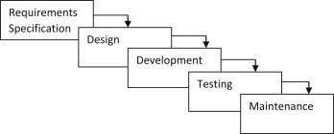

Figure 3.1: Waterfall Model

### 1. Planning and requirement analysis

Each software development life cycle model starts with the analysis, in which the stakeholders of the process discuss the requirements for the final product. The goal of this stage is the detailed definition of the system requirements. Besides, it is needed to make sure that all the process participants have clearly understood the tasks and how every requirement is going to be implemented. Often, the discussion involves the QA specialists who can interfere the process with additions even during the development stage if it is necessary.

### 2. Designing project architecture

At the second phase of the software development life cycle, the developers are actually designing the architecture. All the different technical questions that may appear on this stage are discussed by all the stakeholders, includ- ing the customer. Also, here are defined the technologies used in the project, team load, limitations, time frames, and budget. The most appropriate project decisions are made according to the defined requirements.

### 3. Development and programming

After the requirements are approved, the process goes to the next stage of actual de- velopment. Programmers start here with the source code writing while keeping in mind previously defined requirements. The system administrators adjust the software environment, front-end programmers develop the user interface of the program and the logic for its interaction with the server. The programming by itself assumes four stages:-

• Algorithm development

• Source code writing

• Compilation

• Testing and debugging

### 4. Testing

The testing phase includes the debugging process. All the code flaws missed during the development are detected here, documented, and passed back to the developers to fix. The testing process repeats until all the critical issues are removed and software work ow is stable.

### 5. Deployment

When the program is finalised and has no critical issues it is time to launch it for the end users. After the new program version release, the tech support team joins. This department provides user feedback; consult and support users during the time of exploitation. Moreover, the update of selected components is included in this phase, to make sure, that the software is up-to-date and is invulnerable to a security breach.

**CHAPTER 4**

## **DESIGN AND MODELLING OF SYSTEM**

Unified Modelling Language (UML) is analogous to the blueprints used in other fields and consists of different types of diagrams. In the aggregate, UML diagrams describe the boundary, structure, and behaviour of the system and the objects within it.

Following UML diagrams have been designed for the project:

1. Use Case Diagram

2. Class Diagram

3. Sequence diagram

4. Activity Diagram

5. State Diagram

### 

### 

### 

### 

### 

### 

### 

### 

### 

### 

### 

### 

### **4.1 Use Case Diagram**

Use case diagrams are usually referred to as [behaviour diagrams](https://www.uml-diagrams.org/uml-25-diagrams.html#behavior-diagram) used to describe a set of actions that some system or systems should or can perform in collaboration with one or more external users of the system. Each use case should provide some observable and valuable result to the actors or other stakeholders of the system.

Figure 1 shows the use case diagram of the system. The following actors used in the use case diagram are student, teacher, system, and cloud. The various use cases used in the diagram are teacher login, view attendance, take attendance, capture photo, process image, take another photo.

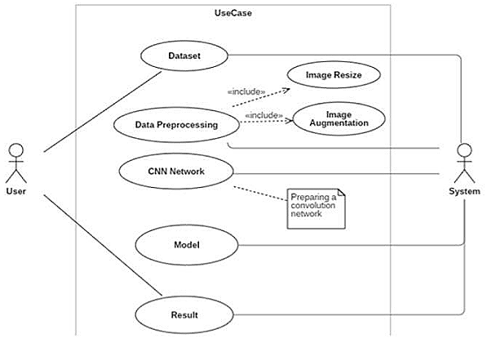

### **Fig 4.1. Use Case Diagram**

### **4.2 Class Diagram**

A class diagram is an illustration of the relationships and source code dependencies among classes in the Unified Modelling Language (UML). In this context, a class defines the methods and variables in an object, which is a specific entity in a program or the unit of code representing that entity.

Figure 2 shows the class diagram of the project, the various classes used in the diagram are user, student, teacher, Image, Cloud, Face Recognition.

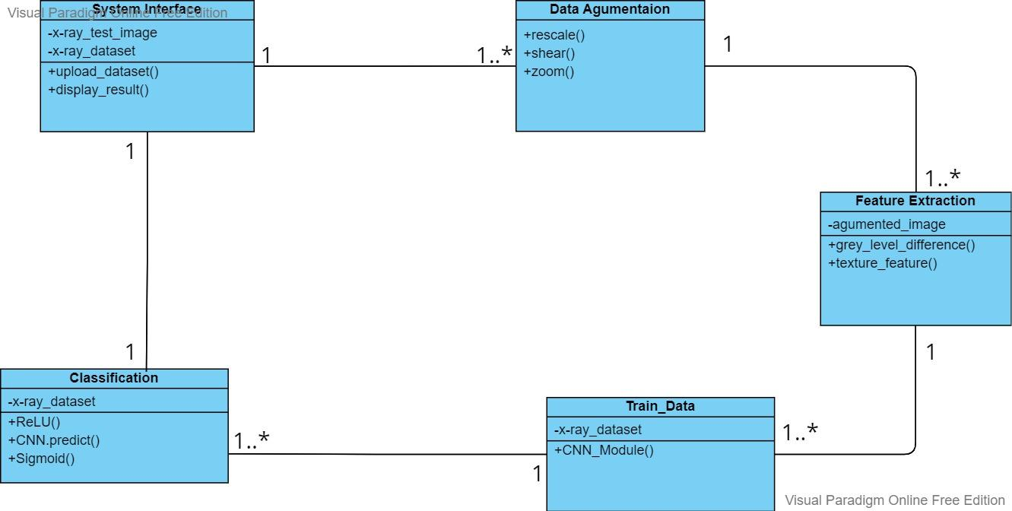

**Fig 4.2. Class Diagram**

### 

### 

### 

### 

### 

### 

### **4.3 Sequence Diagram**

Sequence diagrams are sometimes called event diagrams or event scenarios. A sequence diagram shows, as parallel vertical lines (lifelines), different processes or objects that live simultaneously, and, as horizontal arrows, the messages exchanged between them, in the order in which they occur

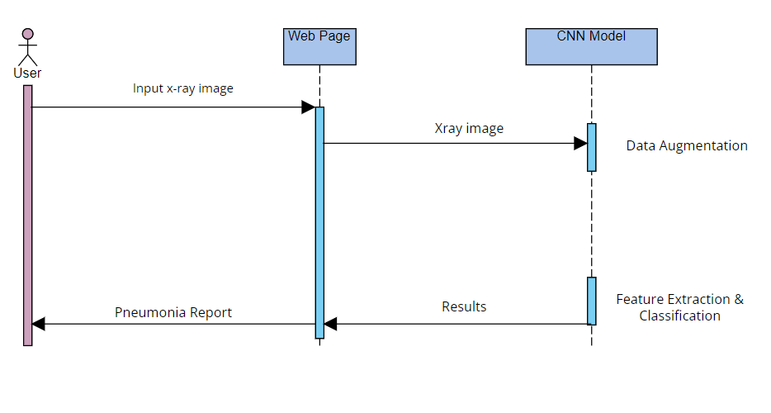

### **Fig 4.3. Sequence Diagram**

### 

### 

### 

### 

### 

### 

### 

### 

### **4.4 Activity diagram**

The activity diagram is another important diagram in UML to describe the dynamic aspects of the system. An activity diagram is basically a flowchart to represent the flow from one activity to another activity. The activity can be described as an operation of the system. The control flow is drawn from one operation to another.

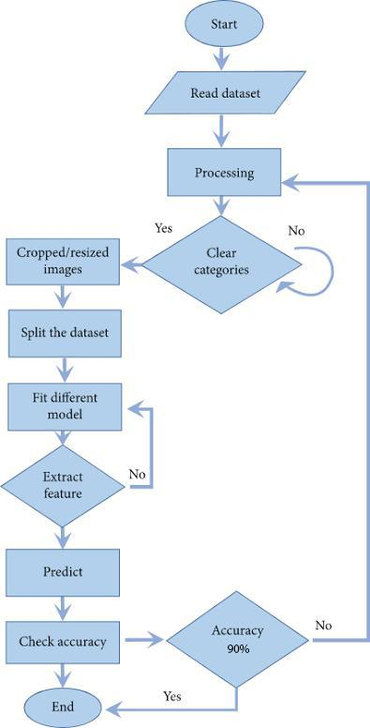

### 

### **Fig 4.4. Activity Diagram**

### 

### 

### 

### 

### **4.5 State Diagram**

A state diagram, sometimes known as a state machine diagram, is a type of behavioural diagram in the Unified Modelling Language (UML) that shows transitions between various objects.

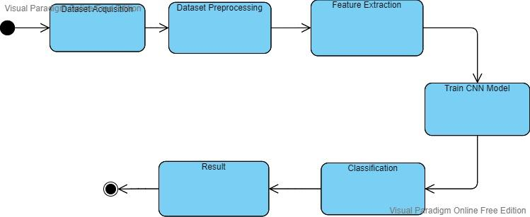

**Fig 4.5. State Diagram**

**CHAPTER 5**

### **ALGORITHM AND METHODS**

5.1 Data Acquisition

The proposed database used to evaluate the performance of the model contains a total of 5863 X-ray photos from the Kaggle.

In 2017 Dr. Paul Mooney started a competition on Kaggle on viral and bacterial pneumonia classification. It contained 5,863 paediatric images; hence it is very different from the other datasets. We are referring to the revised version of this dataset.[6]

In addition, the database is organised into three folders (Train, Test, Val) and contains subfolders for each category of image (Pneumonia / General). All images have been resized to a static, A few examples of common and pneumonia images are listed in Figure 1. Chest X-ray images always have signs of limited brightness on account of the low dose of exposure in patients, due to chest X-ray images always containing black, white, and grey pants. The lungs are located on both sides of the thoracic cavity and the lung area can be easily detected by X-ray, which is almost black. The heart, located between the lungs, appears almost as white as X-rays can completely pass through the heart. Bones are made of protein and very dense, so X-rays cannot cross it and the bones are shown almost white. Ku moreover, the bones have clear edges.

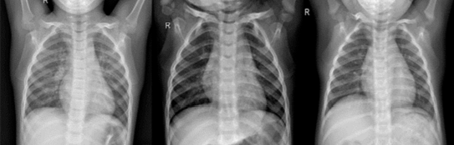

(a)

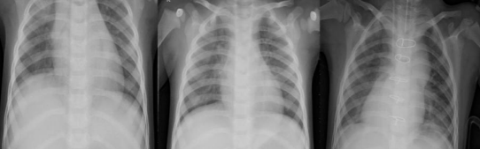

(b)

**Fig 5.1 Examples from the dataset. (a) normal cases (b) pneumonia cases**

5.2 Data Pre-processing

The strategies used throughout this paper are listed in Table 2. In our study,

rescale is a value by which we will multiply the data before any other processing. Our original images consist of RGB coefficients in the 0-255, but such values would be too high for our models to process (given a typical learning rate), so we target values between 0 and 1 instead of by scaling with a 1/255. factor. shear range is for randomly applying shearing transformations zoom range is for randomly zooming inside pictures, horizontal flip is for randomly flipping half of the images horizontally --relevant when there are no assumptions of horizontal asymmetry (e.g. real-world pictures)

Data pre-processing techniques used in this study

|  |  |
| --- | --- |
| Rescale | 1./255 |
| Zoom Range | 0.2 |
| Shear Range | 0.2 |
| Horizontal Flip | True |

**Table 2**

5.3 Proposed Network

In this study, we designed a VGG-based CNN model to extract the features of chest X-ray images and use those features to detect if a patient suffers from pneumonia. In Our CNN Architecture, we began it with a lower filter value of 32 and increased it layer-wise. Constructed the model with a layer of Conv2D followed by a layer of Carpooling. The kernel size is preferred to be an odd number like 3x3.

Tanh, ReLU, etc. can be used for activation function, but ReLU is the most preferred activation function. input shape takes in image width & height with the last dimension as a colour channel. then we Flatten the input after CNN layers and added ANN layers.

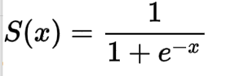

f(x)=max(0,x)

*S(x) = Sigmoid*

*f(x) = ReLU*

Used activation function as SoftMax for the last layers(ANN Layers) also defined units as the total number of classes and used sigmoid for binary classification and set unit to 1.

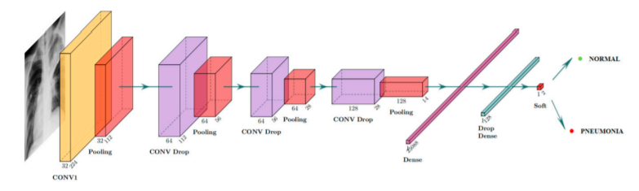

**Fig 5.2. Details of proposed DL mode**

## **CHAPTER 6**

**Implementation and Testing**

**6.1 Data Acquisition**

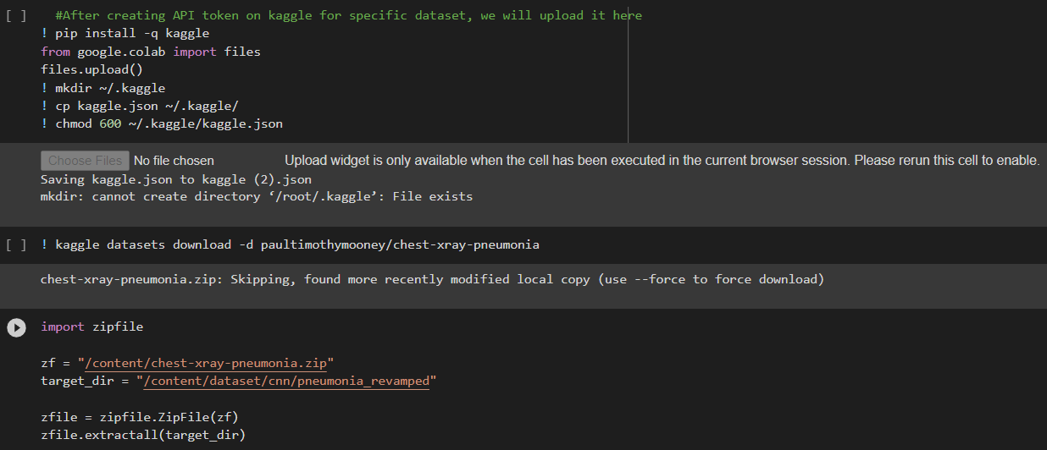

**Fig 6.1.1 setting up Kaggle in colab**



**Fig 6.1.2 importing dataset from kaggle in colab**



**Fig 6.1.3 extracting downloaded dataset in colab**

**6.2 Data Augmentation**

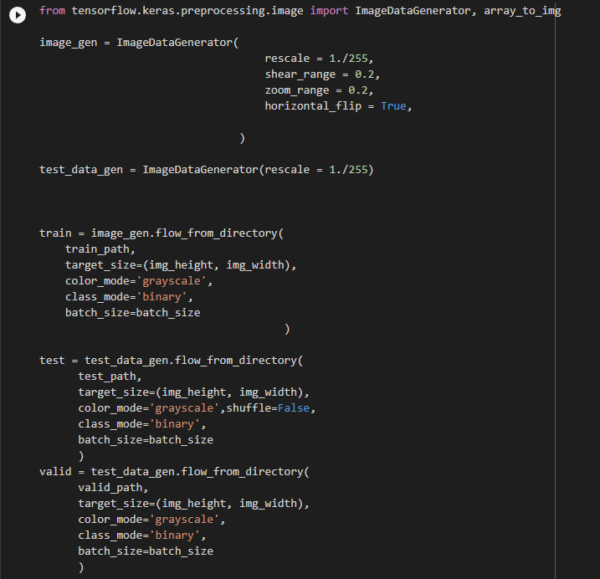

**Fig 6.2.1 Defining parameters for Data augmentation**



**Fig 6.2.2 Applying defined parameters to Train, Test & Valid sets**

Using the “tensorflow.keras.preprocessing.image” library, for the Train Set, we created an Image Data Generator that randomly applies defined parameters to the train set and for the Test & Validation set, we’re just going to rescale them to avoid manipulating the test data beforehand.

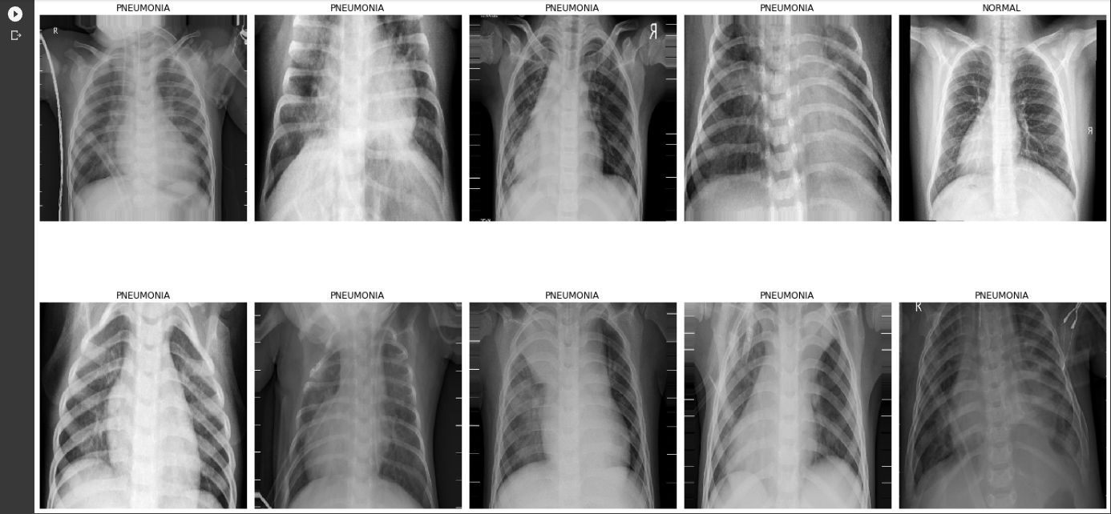

**Fig 6.2.3 Augmented Dataset images**

We have analysed the performance of these bellow CNN architectures namely; AlexNet, ResNet-50, and VGGNet-16. [3]

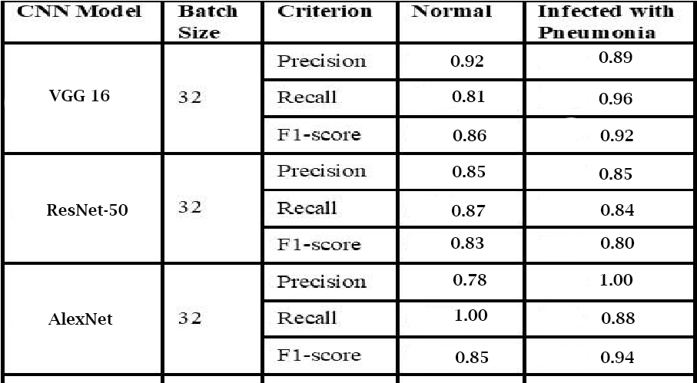

## Table 3. Analysis of model Performance for CNN Models with 32 Batch Size

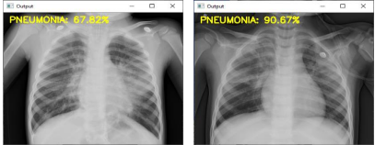

Fig 6.3 ResNet-50

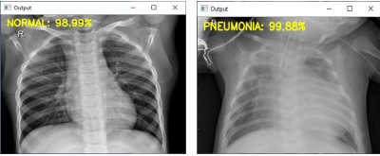

Fig 6.4 AlexNet

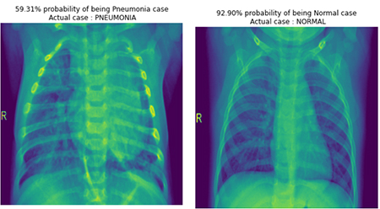

Fig 6.5 VGG16

## **CHAPTER 7**

**Evaluation**

7.1 Image pre-processing

We'll use an Image Augmentation approach to artificially boost the size of the image training dataset.

Image Augmentation increases the size of the dataset by creating a modified version of the existing training set photos, which increases dataset variation and, as a result, improves the model's ability to predict new images.

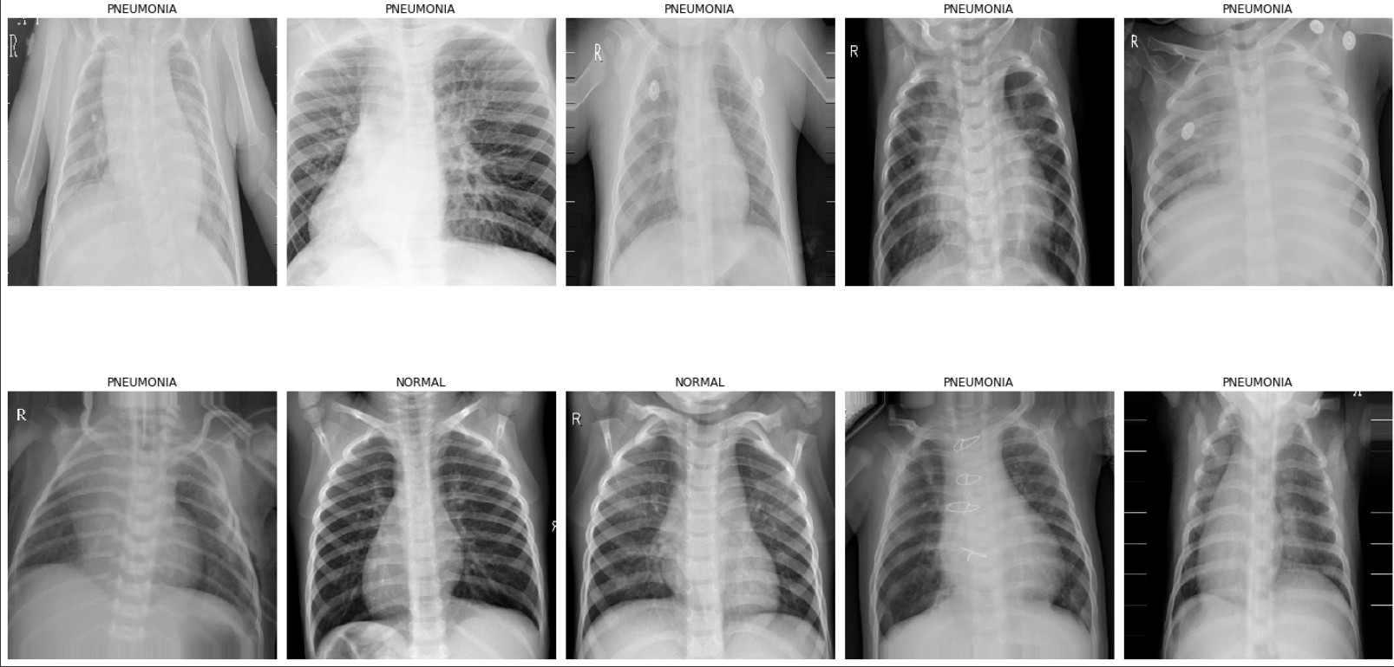

**Fig. 7.1 Augmented Dataset Images**

**Some Image Data Generator settings are defined as follows: -**

**rescale** - Each digital image is made up of pixels with values ranging from 0 to 255, with 0 representing black and 255 representing white. As a result, rescale the scales array of the original picture pixel values to [0,1], ensuring that the photos contribute evenly to the overall loss. Otherwise, a higher pixel range image causes more loss and should be utilised with a lower learning rate, whereas a lower pixel range image requires a higher learning rate.

**shear range** - The shear's transformation is the image's shape. It fixes one axis and extends the image at a specific angle called the shear angle.

The image has been magnified by a zoom of less than 1.0. The image has been zoomed out by more than 1.0.

**horizontal flip** - At random, certain photos are flipped horizontally.

**vertical flip** - At random, some photos are flipped vertically.

**roataion range** - The image is rotated randomly between 0 and 180 degrees.

**width shift range** - Horizontal shifts the image.

**height shift range** - Vertically shifts the image.

**brightness range** - a brightness of 0.0 means there is no light, and 1.0 means there is a lot of light.

**fill mode** - Fills the image's missing value with the nearest value, wrapped value, or reflected value.

7.2 Confusion Matrix

Let’s interpret the output of the confusion matrix. The upper left (TP) denotes the number of images correctly predicted as normal cases and the bottom right (TN) denotes the correctly predicted number of images as cases of pneumonia. As Pneumonia case, the upper right denotes the number of incorrectly predicted images but were actually normal cases and the lower left denotes the number of incorrectly predicted Normal case images but were actually Pneumonia case.

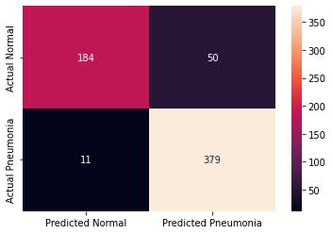

**Fig. 7.2 Confusion Matrix**

7.3 Visualizing some predicted images with percentage %

##### ‘

**Fig. 7.3 Predicted Images**

* This provides you a percentage estimate of the individual image, which you may load straight from your hard drive by specifying its path.
* After importing the image as we did previously, we must recreate all of the data pretreatment procedures in order to input the test set into the model and obtain a forecast. Importing the tensorflow.keras.preprocessing.image class is required for pre-processing.
* Import an image with dimensions of (500,500) and a grayscale colour channel.
* To predict the case, convert the image to an array, rescale it by dividing it by 255, and extend dimension by axis = 0 as shown earlier.

7.4 User Interface

## **Using Streamlit**

Streamlit is an open-source python framework for building web apps for Machine Learning and Data Science. We can instantly develop web apps and deploy them easily using Streamlit. Streamlit allows you to write an app the same way you write a python code. Streamlit makes it seamless to work on the interactive loop of coding and viewing results in the web app.

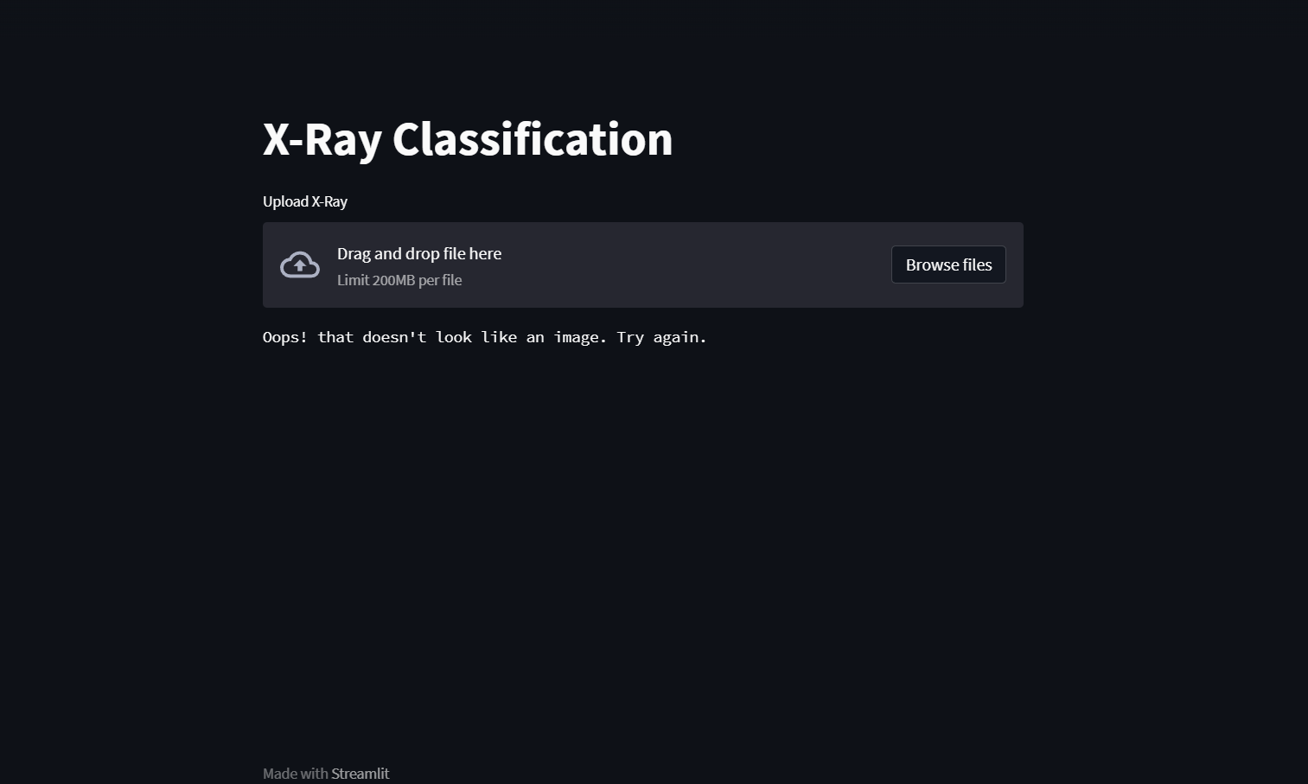

**Fig. 7.4 Streamlit User Interface**

**CHAPTER 8**

**Publication**

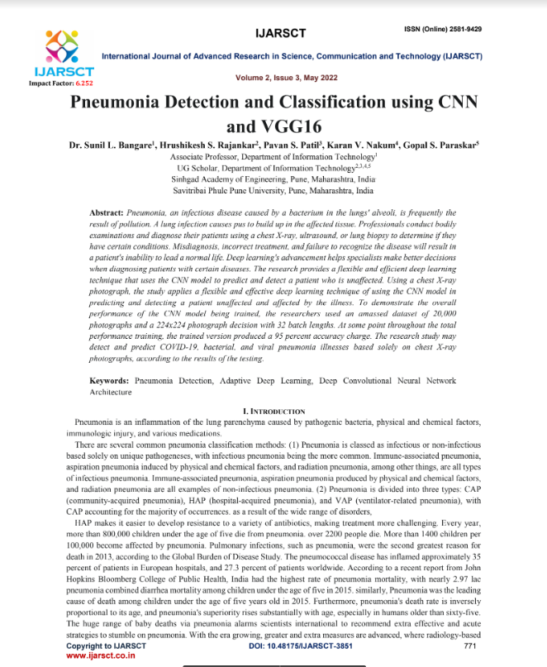

**CHAPTER 9**

**Conclusion**

This study describes a CNN-based model aiming to diagnose pneumonia on a chest X-ray image set. The contributions in this paper are listed as follows. We designed a simple VGG-based

CNN model to extract the features from original images or previous feature maps, which contained only six layers combining ReLU activation function, drop operation, and max-pooling layers. The results of the obtained accuracy rate of 96.07% and precision rate of

94.41%, shows that our proposed model performs well in comparison to state-of-the-art CNN model architectures. To illustrate the performance of our proposed model, several comparisons of different input shapes and loss functions were provided.

In the future, we will continue the research to explore more accurate classification architectures to diagnose two types of pneumonia, viruses, and bacteria. According to the description discussed above, the CNN-based model is a promising method to diagnose the disease through X-rays.

## 

## 

## 

## 

## 

## **CHAPTER** **10**

## **References**

[1] Vandecia Fernandes et al., “Bayesian convolutional neural network estimation for pediatric pneumonia detection and diagnosis”, Computer Methods and Programs in Biomedicine, Elsevier, 2021

[2] Hongen Lu et al., “Transfer Learning from Pneumonia to COVID-19”, Asia-Pacific on Computer Science and Data Engineering (CSDE), 2020 IEEE

[3] Sammy V. Militante et al., “Pneumonia and COVID-19 Detection using Convolutional Neural Networks”, 2020 the third International on Vocational Education and Electrical Engineering (ICVEE), IEEE, 2021

[4] Nanette V. Dionisio et al., “Pneumonia Detection through Adaptive Deep Learning Models of Convolutional Neural Networks”, 2020 11th IEEE Control and System Graduate Research Colloquium (ICSGRC 2020), 8 August 2020

[5] Md. Jahid Hasan et al., “Deep Learning-based Detection and Segmentation of COVID-19 & Pneumonia on Chest X-ray Image”, 2021 International Information and Communication Technology for Sustainable Development (ICICT4SD), 27-28 February 2021

[6]<https://www.kaggle.com/paultimothymooney/chest-xray-pneumonia>

[7] LeCun, Y.; Boser, B.; Denker, J.S.; Henderson, D.; Howard, R.E.; Hubbard, W.; Jackel, L.D. Backpropagation applied to handwritten zip code recognition. Neural Comput. 1989, 1, 541–551.

[8] Krizhevsky, A.; Sutskever, I.; Hinton, G.E. Imagenet classification with deep convolutional neural networks. Adv. Neural Inf. Process. Syst. 2012, 25, 1097–1105.

[9] Simonyan, K.; Zisserman, A. Very deep convolutional networks for large-scale image recognition. arXiv 2014, arXiv:1409.1556

[10] R. R. Selvaraju, M. Cogswell, A. Das, R. Vedantam, D. Parikh and D. Batra, "Grad-CAM: Visual Explanations from Deep Networks via Gradient-Based Localization," 2017 IEEE International Conference on Computer Vision (ICCV), Venice, 2017, pp. 618-626.

[11] L. Wang and A. Wong, "COVID-Net: A tailored deep convolutional neural network design for detection of COVID-19 cases from chest radiography images," arXiv:2003.09871, 2020.

[12]<https://towardsdatascience.com/medical-x-ray-%EF%B8%8F-image-classification-using-convolutional-neural-network-9a6d33b1c2a>

[13] Dr. Sunil L. Bangare, Hrushikesh S. Rajankar, Pavan S. Patil, Karan V. Nakum, Gopal S. Paraskar “Pneumonia Detection and Classification using CNN and VGG16”, Sinhgad Academy of Engineering, Pune, Maharashtra, India

https://doi.org/10.48175/IJARSCT-3851

## 

## 